aFor the Webpage, you are required to create the ElementTypesConfiguration model, there is a generation facility provided by Papyrus but it generates imcomplete models (due to the migration problem caused by Oxygen). You may make use of this facility.

To create the model manually you need to do new -> others -> ElementTypesConfiguration Model.

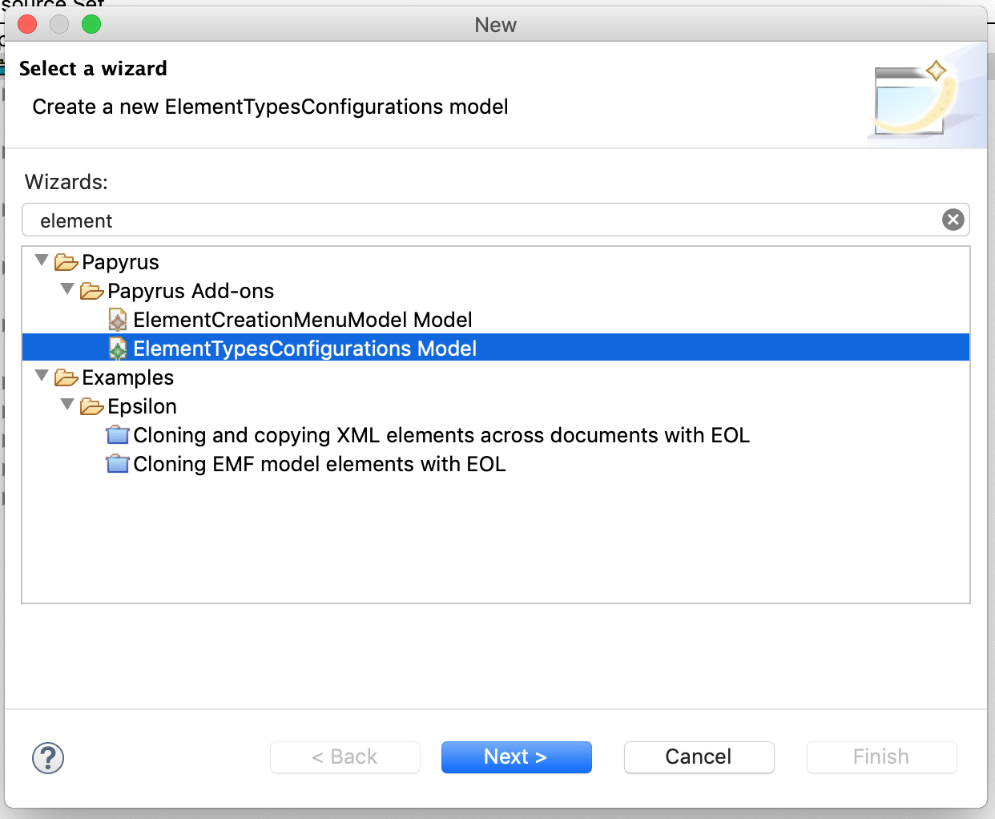

When asked, select the Element Type Set Configuration as the root element.

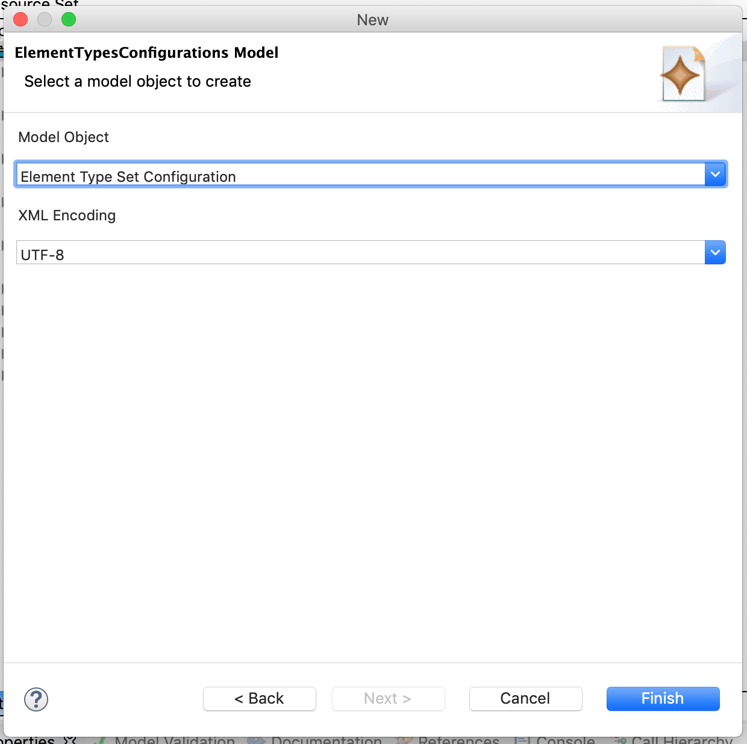

Below is the detailed model elements you need to create within your ElementTypesConfiguration model.

Thus, you are required to do the following:

1. Create a SpecialisationTypeConfiguration for each of the Stereotypes you defined in your UML profile. For the features:

* Hint: UML::Class or UML::Association depending on your Stereotype
* Identifier: give it a meaningful identifier
* Kind: org.eclipse.gmf.runtime.emf.type.core.IHintedType
* Name: give it a meaningful name
* Specialised Types: For Class you should look for the UML::Class, which is a MetamodelTypeConfiguration; For Association you should look for the UML::AssociationBase, which is also a MetamodelTypeConfiguration.

1. Create a StereotypeApplicationMatcher for the SpecialisationTypeConfiguration you created in Step 1). For the features:

* Profile URI: You should use the uri you defined in your UML profile
* Stereotypes Qualified Names: You should follow the form: "ProfileName::StereotypeName", for example, if you name your profile "website", then for the "Web" Stereotype, the qualified name should be **website::Web**

1. Create another SpecialisationTypeConfiguration - this is how you specify what shape your Stereotype should follow. For the features:

* Hint: Class_Shape or Association_Shape depending on your stereotype
* Identifier: give it a meaningful identifier
* Kind: org.eclipse.gmf.runtime.emf.type.core.IHintedType
* Name: give it a meaningful name
* Specialised Types: For Class you should look for the "Class Shape", which is a SpecialisationTypeConfiguration; For Association you should look for the "Association Shape". Note: you should also include the SpecialisationTypeConfiguration you created in step 1) in the list.

1. For each Stereotype, you should create an ApplyStereotypeAdviceConfiguration, its features:

* Identifier: give it a meaningful identifier
* Inheritance: none
* Target: look for the SpecialisationTypeConfiguration you created in Step 1.

1. Create a StereotypeToApply in your ApplyStereotypeAdviceConfiguration in Step 4), its features:

* Required Profiles: provide the name of your profile
* Stereotype Qualified Name, please refer to step 2)
* Update Name: true

**Note: you have 20 minutes to complete this task.**